DDI Longterm Infrastructure Manifesto: Outline as of 25 October, 2016

- Overview (Jared, Katja)
  - Motivation
  - Purpose
  - Benefits

Benefits to achieve in the infrastructure system: (& other goals)
- Automate capture of metadata (reduced costs and time)
- Capture better/more complete metadata
- Enable new data discovery and analysis tools
- New data harmonization, comparison and combination tools
- Systems that can be used/across organizations; Transparency across organizations across or w/in stages of the life cycle
- Encourage interoperability and comparability across studies, domains, and countries
- Infrastructure for small scale w/o benefits to overhead
- Lower cost of using/entry into DDI infrastructure (barriers to entry)
- Faster and more efficient research/data collection design design
- Reproducibility
- Credit for producing items in the life cycle
- Increased use of DDI; tool that’s used at (and enhances) all stages of research w/in infrastructure
- Purpose: support discovery, analysis, preservation, harmonization, reuse to enable future research more easily
- Inclusions and exclusions; can incorporate variety of observational data while intersecting with/relying up on other standards as appropriate
- Multi-lingual and multi-country environment

  - What this document is not/caveats

- Vision for long term infrastructure for the social sciences (George)
  - Example use case: Survey design

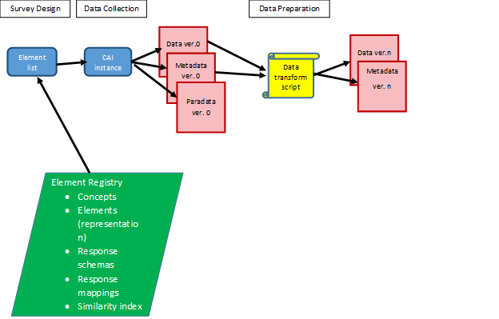

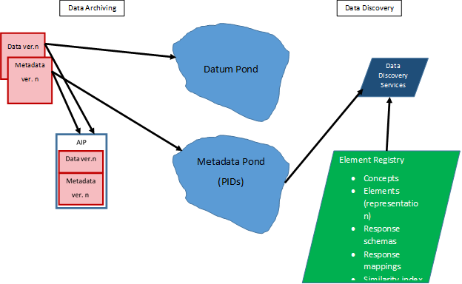

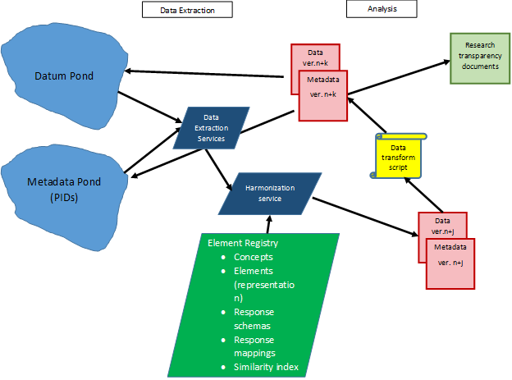

- Integrating DDI into the Data Lifecycle
  - Element registry
  - Instrument Design
  - Data transformation
  - Archiving
  - Data Discovery
  - Data extraction
  - Data merge
  - Data analysis
- Lifecycles of other data types
  - Administrative data (Katy?)
  - Other data with existing metadata standards (e.g. EHR)
  - Other object types: images, text, video, etc.
- Stakeholders (Katy) (includes types (T), needs (N)
  - Data producers:
    - Research, administrative, other; academic, government, other
    - T: Large-scale
      - T: Survey designers
        - T: Academic and government
        - N: Re-use of existing survey components
        - N: Design new survey components
        - N: enable changes in measurement while maintaining comparability over time
        - N: ability to integrate various types of measures (biometric, open-ended responses, etc.)
      - T: Survey operations
        - T: may/may not be one and the same as survey designers
        - T: Academic, government, and commercial
        - N: ease of receipt of requirements from designers
      - N: Reproducibility/transparency (incl. ability to track their work)
      - N: Greater efficiency in doing their research
      - N: demonstrating use and impact of the data they produce
      - N: Discoverability of their data
    - T: Small-scale
      - N: Ability to document their research/create metadata as they do their work w/minimal additional cost of using DDI (i.e., integrating into existing tools they use)
      - N: Reproducibility/transparency (incl. ability to track their work)
      - N: Greater efficiency in doing their research
      - N: demonstrating use and impact of the data they produce
      - N: Discoverability of their data

  - Data subjects/survey participants
    - N: confidentiality
    - N: demonstration of public benefit resulting from their participation
  - Data repositories
    - T: broad, specialized, archives, self-publishing platforms
    - N: provide access to data at various levels (given issues of licensing and confidentiality)
    - N: Enable discovery and analysis by end-users; incl. enable discovery in tools beyond their own catalogs (e.g., virtual metadata pond, but also linking data and publications)
    - N: Preservation (for some)
    - N: Richer metadata accompanying deposits, as well as more to be added/tracked throughout their workflows (which will improve ease/speed of processing pipeline and provide a higher-quality product)
    - N: demonstrating use and impact of the data they make available
    - N: ability to build upon/learn from the work/systems/tools that others have done to better leverage resources
  - Data users:: Secondary data users (note: includes academia and beyond (public sector, non- and for-profits, etc.) and people with various levels of skill and expertise
    - N: Discovery (known-item and by features (topic, time, geography, etc.)) across multiple data sources and repositories; includes discovery at the variable level
    - N: Analysis (remote and on desktop) (given varied skill levels)
    - N: Linking and combining datasets from different sources (esp. in new ways)
    - N: Comparing change (over time, geography, etc.)
    - N: Reproducibility/transparency (incl. ability to track their work)
    - N: Using data as part of teaching research methods
    - [placeholder for referencing data producers as data users as well]
  - Funding agencies
    - Large-scale national agencies
      - National Science Foundation (NSF)
      - National Institutes of Health (NIH)
      - Deutsche Forschungsgemeinschaft (DFG)
      - Economic and Social Research Council (ESRC), and potentially others, within the broader umbrella for Research Councils (Department for Business, Energy and Industrial Strategy)
      - Swiss National Science Foundation (SNF)
      - Swiss Commission for Technology and Innovation (CTI)
      - Fill in others here; especially international examples
    - Large-scale international agencies
      - European Commission (EC) - especially Horizon 2020 and Eurostars program
      - Organisation for Economic Co-operation and Development (OECD)
      - World Bank
    - Ministries
    - Private Research Foundations
      - Alfred P. Sloan Foundation
      - Wellcome Trust (esp. as relates to biomedical)
      - Fill in others here
    - Other Government
      - Institute of Museum and Library Services
      - Other

    - Universities
  - Other standards:
    - N: having DDI complement their standard by documenting aspects they don’t cover
  - (DDI) Tool/service developers (often would live in one of the aforementioned stakeholder organizations):
    - N: Having their tools widely known and adopted
    - N: Awareness of other tools upon which they can build
    - N: Finding collaborators to co-create tools when a need is shared by multiple organizations
    - N: Long-term hosting and maintenance of tools
  - Members of the public:
    - N: to gain a benefit for society from data gathered and used
  - Other communities
- Services and Tools (Ingo)
  - Instrument design
  - Data creation
  - Documentation tools
  - Need to define format for Datum Pond
  - Need to define format for Metadata Pond (PIDs)
  - Tools needed for Element Register
    - Submission
    - Curation
    - Discovery
    - Survey Design
- Strategies for realizing the vision
  - Building on existing tools and projects
  - Utilizing related standards
  - Research and demonstration projects
  - How to engage stakeholders
- Next steps
  - Grant application components
  - Publications
  - Coordination

