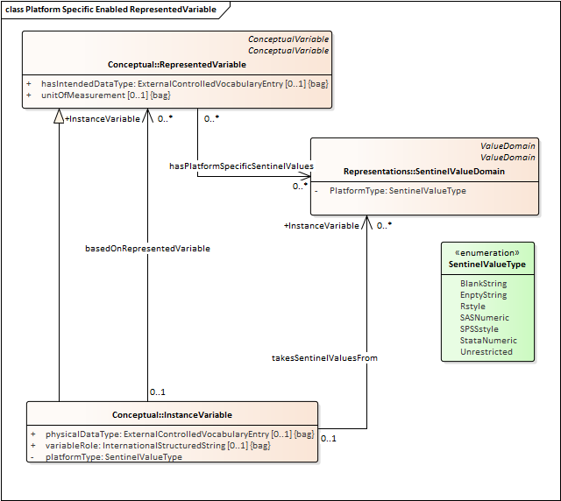

- SASNumeric - codes drawn from . ._ .A .B .C .D .E .F .G .H .I .J .K .L .M .N .O .P .Q .R .S .T .U .V .W .X .Y .Z Sentinel code treated as less than any substantive value
- StataNumeric - codes drawn from . ._ .A .B .C .D .E .F .G .H .I .J .K .L .M .N .O .P .Q .R .S .T .U .V .W .X .Y .Z Sentinel code treated as greater than any substantive value
- SPSSstyle - System missing (a dot) a set of individual values drawn from the same datatype as the SubstantiveValueDomain, and a range of values drawn from the same datatype as the SubstantiveValueDomain. Comparisons return system missing. Some functions substitute with valid values (e.g. SUM replaces missing values with 0)
- Rstyle - Codes drawn from NA and the IEEE 754 values of NaN -Inf +Inf. Comparisons return NA.
- Unrestricted - No restrictions on codes for sentinel values. Use in comparisons is indeterminate.
- EmptyString - An empty string indicates missing. Use in comparisons returns missing.
- BlankString - A Blank string indicates missing. Comparison is based on lexical order.

