Example for gender dependent questions

http://zis.gesis.org/skala/Schwartz-Breyer-Danner-Human-Values-Scale-(ESS)

2 Instrument

Instruction
Now I will briefly describe some people. Please listen to each description and tell me how much each person is or is not like you. Use this card for your answer.

Items
The scale consists of 21 short verbal portraits of different people describing the importance of different values to them. For each item, respondents indicate how similar the person described in the item is to themselves. Thus, respondents’ personal values are inferred from the implicit values of the people they view as similar to themselves. The items of the Human Values Scale (ESS, 2012) are shown in Table 1. There are separate versions of the questionnaire for male and female participants. The belonging footnotes are likewise attached to the items in the ESS 2012 questionnaire.

Table 1
Items of the Human Values Scale (ESS)
No
Item
Subscale
1
Thinking up new ideas¹ and being creative is important to him/her. He/she likes to do things in his/her own original way.
Self-Direction
2
It is important to him/her to be rich. He/she wants to have a lot of money and expensive² things.
Power
3
He/she thinks it is important that every person in the world should be treated equally. He/she believes everyone should have equal opportunities in life.
Universalism
…..
Example for male repsondents: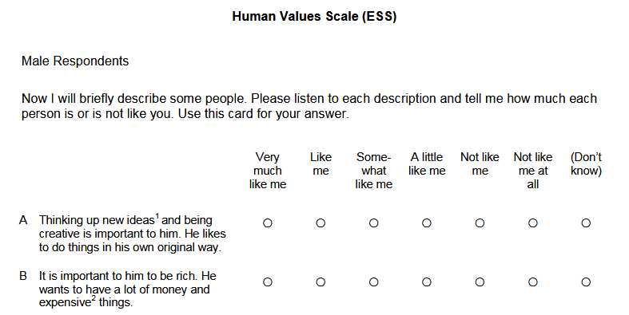

ConceptualInstrument
- WorkflowStepSequence/MasterSequence
  - displayLabel “Human Values Scale (ESS)”
  - WorkflowStepIndicator “1”
    - WorkflowStep is an Act is an InstrumentComponent is a Statement
    - statementText is DynamicText
      - content is TextContent as a LiteralText
        - text “Now I will briefly describe some people. Please listen to each description and tell me how much each person is or is not like you. Use this card for your answer.”
  - WorkflowStepIndicator “2”
    - WorkflowStep is an Act is an InstrumentComponent is an InstanceQuestion - name “A”
    - Instantiates RepresentedQuestion (see below)
  - WorkflowStepIndicator “3”...

- organizes Capture as a RepresentedQuestion
    - questionText to DynamicText
      - Content to TextContent as a LiteralText
        - text “Thinking up new ideas¹ and being creative is important to him/her. He/she likes to do things in his/her own original way.”

