Simple Questionnaire Example 1 “Smoking”
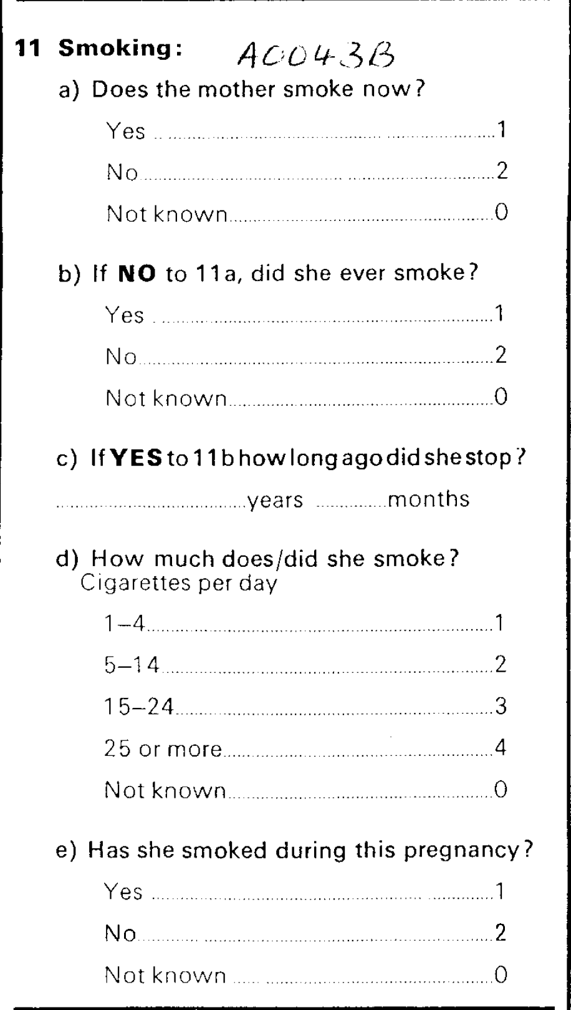

Conceptual instrument to hold the questionnaire
- displayLabel “British Births”

- WorkflowStepSequence/MasterSequence
  - displayLabel “11 Smoking”
  - WorkflowStepIndicator “1”
    - WorkflowStep is an Act is an InstrumentComponent is an InstanceQuestion - name “a)”
    - Instantiates RepresentedQuestion (see below)
  - WorkflowStepIndicator “2”

    - WorkflowStep is an IfThenElse
      - Condition is a CommandCode
        - Command
          - commandContent string: “if NO to 11a”
      - inputParameter
        - Parameter ValueDomain [Problem is abstract?] “2”
        - [Problem: how to identify array like “Q11a=2” as parameter?]
      - containsSubSequence WorkflowStepSequence
        - WorkflowStepIndicator “3”
        - WorkflowStep is an InstrumentComponent is an InstrumentComponent is an InstanceQuestion - name “b)”
        - Instantiates RepresentedQuestion (see below)

        - WorkflowStep is an IfThenElse
          - Condition is a CommandCode
            - Command
              - commandContent string: “if YES to 11b”
          - inputParameter
            - Parameter ValueDomain [Problem is abstract?] “1”
            - [Problem: how to identify array like “Q11b=1” as parameter?]
          - containsSubSequence WorkflowStepSequence
            - WorkflowStepIndicator “4”
            - WorkflowStep is an InstrumentComponent is an InstrumentComponent is an InstanceQuestion - name “c)”
            - Instantiates RepresentedQuestion (see below)

      - WorkflowStepIndicator “5”...
- organizes Capture as a RepresentedQuestion
    - agency, id, version: “uk.closer”, “Question_534573”, “1.0.0”
    - localId “A0043B” (for example…)
    - questionText to DynamicText
      - Content to TextContent is a LiteralText
        - text “Does the mother smoke now?”
    - hasResponseDomain
    - Is a CodeListResonseDomain
      - Has a CodeList
        - Contains CodeIndicator
          - Index “1” (sequence of codes)
          - Code
            - CodeValue “1”
            - References Category (see below)
          - Code
            - CodeValue “2”
            - References Category (see below)
          - Code
            - CodeValue “3”
            - References Category (see below)
      - References CategorySet
        - Category
          - name “Yes”
        - Category
          - name “No”
        - Category
          - name “Not known”
    - In case of open ended question: Is a TextResonseDomain
    - In case of numeric question: Is a NumericResonseDomain

- organizes Capture as a RepresentedQuestion
    - questionText “If NO to 11a, did she ever smoke?”
    - hasResponseDomain
    - Is a CodeListResonseDomain
      - Has a CodeList (see above)
      - References CategorySet (see above)

Issues:
- What is the difference between “name” and “displayLabel” of the Instrument?
- When looking at “ResponseDomain” we did not see that “CodeListResponseDomain” is an extension to it - we were looking for the CodeList in there...
- Issue: Mode of Instrument like Paper-and-pencil, telephone etc should be explicit define. Currently we only have “typeOfInstrument” using a CV that is not specified in more detail
<ImplementedInstrument>
<Id>INSTRUMENT_8344</Id>
<TypeOfInstrument>
<ControlledVocabularyAgencyName>DDI Alliance</ControlledVocabularyAgencyName>
<ControlledVocabularyID>urn:ddi-cv:TypeOfInstrument</ControlledVocabularyID>
<ControlledVocabularyName>TypeOfInstrument</ControlledVocabularyName>
<ControlledVocabularyVersionID>urn:ddi-cv:TypeOfInstrument:1.0</ControlledVocabularyVersionID>
<Content>Questionnaire.Structured</Content></TypeOfInstrument></ImplementedInstrument>

Issue: TextContent is a substitution group with LiteralText or DynamicText: This is not easy to understand for us (normal people), and in the class description on lion it is not possible to click on the elements LiteralText/DynamicText (you have to do a search).

