Simple Questionnaire Example 4

Relationship question - concept

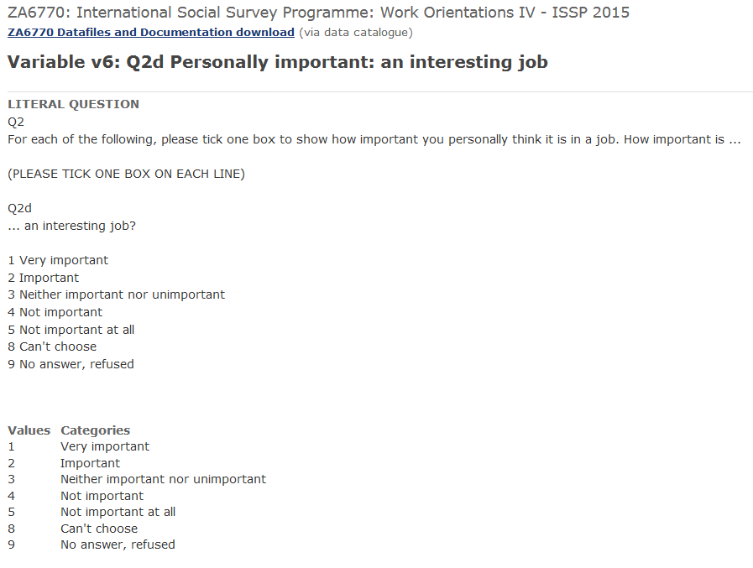

Capture as RepresentedQuestion
    - questionText to DynamicText
      - Content to TextContent is a LiteralText
        - text “For each of the following, please tick one box to show how important you personally think it is in a job. How important is ...an interesting job?”
    - hasConcept to Concept
      - definition to InternationStructuredString “Job Importance”

Relationship question - (sub-)universe
Issue: To document a universe that is part of the question definition, we did not find a good place to document it. E.g. (see Simple Questionnaire Example 1): If a person is smoking, we can ask how long he/she is smoking already. The sub-universe is “smokers” and needs to be documented on the question level. An option for documentation is to use “usage” property of RepresentedQuestion, but usage of “usage” is described to contain “in which ways the object is employed” - not the right thing for us.

A second understanding of universe applies to the universe of the datacollection: If for some reason a question is only applied to certain respondents, this is a filter and can be documented like shown in Simple Questionnaire Example 1. In this case the universe should be related to the datacollection element and not to a specific question.

Relationship question - mode of data collection
Capture as RepresentedQuestion
    - questionText to DynamicText
      - Content to TextContent is a ConditionalText
        - expression to CommandCode
          - Command
            - commandContent string: “if mode=PAPI”

        - []Issue: no text property to hold the actual question wording in case of PAPI]”
      - [maybe repeat the Content element to hold the question wording?]

Relationship question - classification/keywords

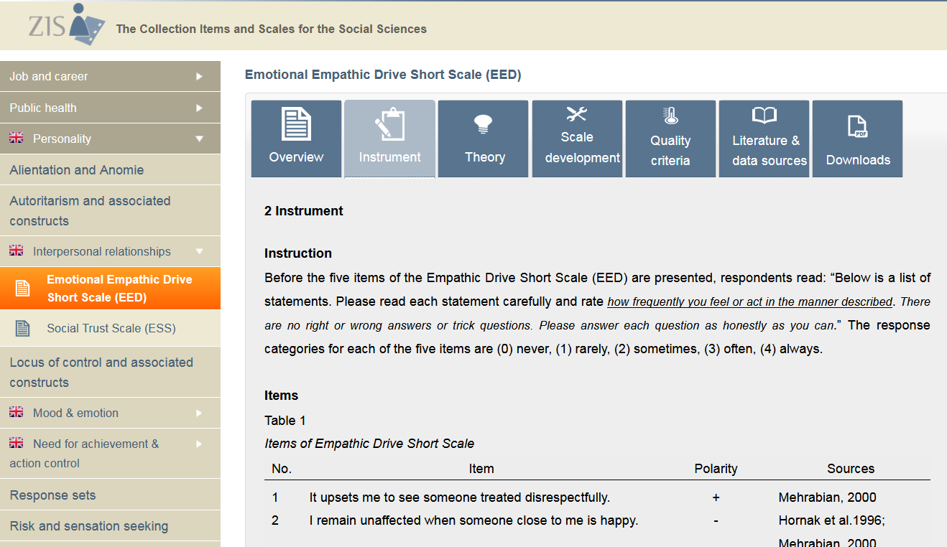

Capture as RepresentedQuestion
    - questionText to DynamicText
      - Content to TextContent is a LiteralText
        - text “It upsets me to see someone treated disrespectfully”
    - Issue: Missing Property Coverage to TopicalCoverage
      - Subject to ExternalControlledVocabularyEntry
        - content “Interpersonal relationships”

Relationship question - publisher/provider
Capture as RepresentedQuestion
    - questionText to DynamicText
      - Content to TextContent is a LiteralText
        - text “It upsets me to see someone treated disrespectfully”
    - hasAnnotation to Annotation
      - creator to AgentAssociation
        - agentName to BibliographicName
          - languagespecificstring to LanguageSpecificString
            - content “Mehrabian”
      - date to AnnotationDate
        - isoDate to IsoDate “2000”

