Use Case Report Back

Audiences
- Implementers - priority for prototype
- Training / Users - for after June

Content Issues
- Raised issues in JIRA of content missing / or relationships not possible
- Some content of use cases not for prototype - this needs review
- Some issues to be further investigated
- Some content have not yet got detailed use cases see list below

Documenting model AND implementation
Documentation is currently bound to the description of the model, but especially where patterns are used, this is not always very helpful for implementation or explaining the use cases
- Separate documentation to cover patterns both the realisation and what this means for usage, e.g. workflow, act/instrument component, and collections / groups.
- Transition for people needing to move their heads from thinking like 2.5 -> 4 and 3.x -> 4
- Change in terminology e.g packages and grouping thinking that derives from collections
- Binding specific documentation - esp RDF change in name cv classnames (it’s in the mapping but still possibly confusing)

Communicating Use Cases
Consistent format for use cases

- Picture of real world example and source
- Indented flow of “DDI elements”
- Visualisation of this - perhaps as a .dot file for insert into .rst documentation
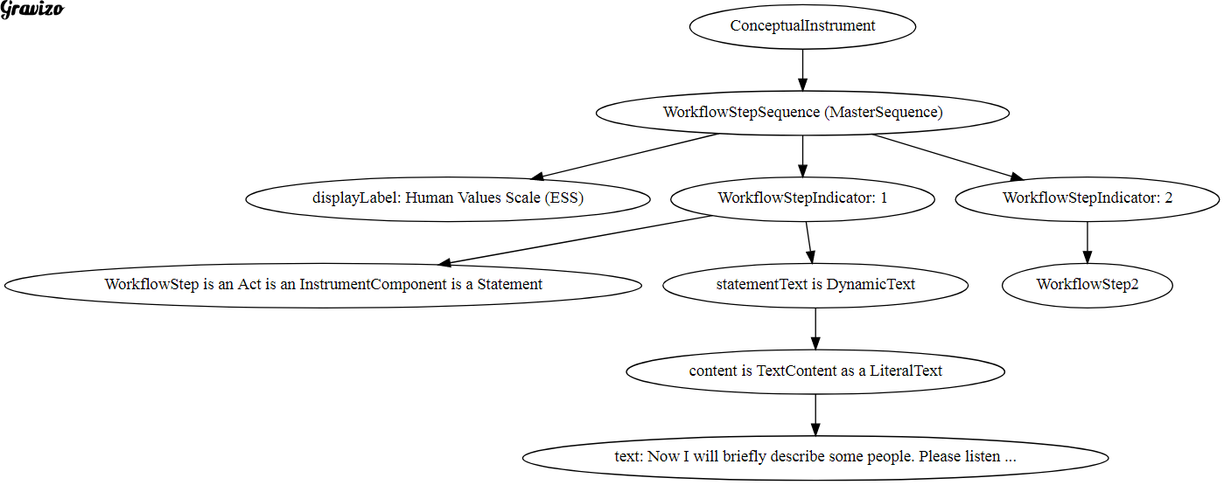

List of completed and to be done use cases

Outstanding Issues
Good use cases for RDF which showcase use of this specific technology
Comparison of things done and things to be done alongside prototype definition

Appendix: Code for example graph

<img src='https://g.gravizo.com/svg?
digraph G {
ConceptualInstrument ->
WorkflowStepSequence ->
displayLabel;
displayLabel [label="displayLabel: Human Values Scale (ESS)"];
WorkflowStepSequence [label="WorkflowStepSequence (MasterSequence)"];
WorkflowStepSequence -> WorkflowStepIndicator;
WorkflowStepIndicator [label="WorkflowStepIndicator: 1"];
WorkflowStepIndicator -> WorkflowStep;
WorkflowStep [label="WorkflowStep is an Act is an InstrumentComponent is a Statement"];
WorkflowStepIndicator -> statementText;
statementText [label="statementText is DynamicText"];
statementText -> content;
content [label="content is TextContent as a LiteralText"];
content -> text;
text [label="text: Now I will briefly describe some people. Please listen ..."];
WorkflowStepSequence -> WorkflowStepIndicator2;
WorkflowStepIndicator2 [label="WorkflowStepIndicator: 2"];
WorkflowStepIndicator2 -> WorkflowStep2;

}
'/>

