Discussion regarding the use of a build server
Minneapolis Sprint, 28 May 2015

Introduction
The idea is to use a cloud-based build server to produce the bundles (ZIP). Currently, this process is controlled by a bash script and runs on the same server as Drupal. A build server would facilitate collaboration and increase the transparency of the build process.

Current design of the build process
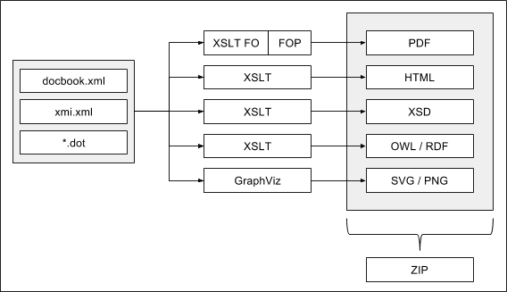

Conclusion
- Everyone seems to think that the use of a build server is a good idea.
- Bamboo is integrated in Atlassian, but we have no experience in using it.
- Jenkins is familiar to us through UKDA and SND, but it is not integrated in Atlassian.
- Dan Smith has offered to take a closer look at Bamboo.

