Identification/Annotation Usage
Currently DDI 4 has the following Identification structures:
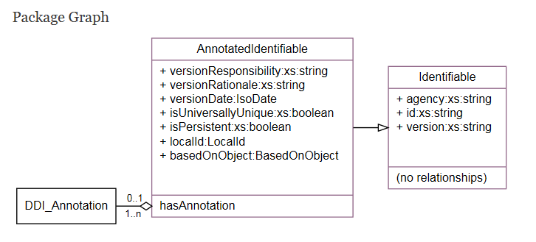
- Identifiable is used to identify objects for the purposes of internal and/or external referencing. Elements of this type are versioned, but contain no information on the nature of the versioning.
- AnnotatedIdentifiable extends Identifiable by adding administrative content on the details of the versioning, local/alternative identification, and intellectual source of the object. It also supports annotation of the object.
- Any Identifiable object could also contain the relation hasAnnotation.
Therefore classes could present the following options:
Class Type | hasIdentification | hasAdministrativeContent | hasAnnotation
ComplexDataType | No | No | No
[illogical]¹ | No | No | Yes
[illogical]² | No | Yes | No
[illogical]^{1,2} | No | Yes | Yes
Identifiable (extension base) | Yes | No | No
Identifiable (extension base) with hasAnnotation | Yes | No | Yes
[Not supported] | Yes | Yes | No
AnnotatedIdentifiable (extension base) | Yes | Yes | Yes

¹Providing an annotation for the purpose of citation assumes that the object can be identified
²Providing an administrative content assumes that the object is managed and can be identified

Question: What defines a use-case for containing Administrative Content?
- Is this differentiation simply a hold-over from DDI-Lifecycle where an Identifiable has an Agency and Version but the first is inherited from the parent Maintainable and the second from the parent Versionable?
- Is there a differentiation between an object which needs a DDI Identification (Agency:Identification:Version) and one that is actively managed needing provenance and other administrative content?
Question: What defines a use-case for having Annotation?
- The class contains intellectual content that can be assigned to a creator (i.e. capturing the name of an individual and their contact information may not reflect intellectual effort, while the creation of an Agent Registry might. The same with a Code and a CodeList.)
Question: What defines a use-case for having Identification?
- An object whose content can serve as a Member of a Collection
- An object whose content may be related to multiple objects (and/or classes)
Question: Is there a use case for a subset of classes that have Identification and Administrative Content but no annotation?
Question: Should an Annotation be Identifiable? It was done so that a number of individual objects could use the same Annotation. However, wouldn’t each object have a separate Title? Also, if it is a collective Annotation, shouldn’t it be at the collection level? How “reusable” is an Annotation?

REFERENCES:
http://lion.ddialliance.org/ddiobjects/Identifiable
http://lion.ddialliance.org/ddiobjects/AnnotatedIdentifiable
http://lion.ddialliance.org/ddiobjects/annotation
DMT-80: Usability over reusability; fundamental questions about DDI 4 https://ddi-alliance.atlassian.net/projects/DMT/issues/DMT-80?filter=allissues
DMFQA-70: Overuse of AnnotatedIdentifiable [contains 2 attachements: IndieficationUsage.xlsx and Overuse of AnntatedIdentifiable.docx] https://ddi-alliance.atlassian.net/projects/DMFQA/issues/DMFQA-70?filter=allissues
Development Review Report: Q1 2015 Development Review – Technical Committee – 2016-03-10 [see Table: Issues for TC to review on next development release, Issue 70 ] https://ddi-alliance.atlassian.net/wiki/display/DDI4/Technical+Committee?preview=/491555/22151197/Development%20Review%20Report_FINAL.docx

