Classifications and Order Relations – Modelling team discussion
This is the model we discussed last time, with a couple of fixes:
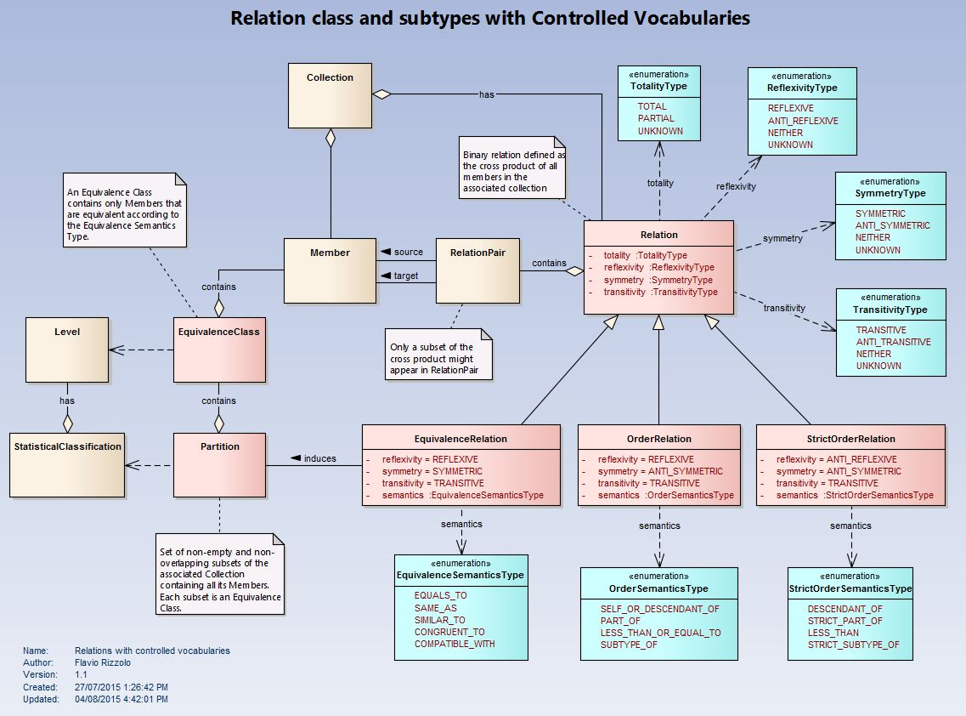
Figure 1
It describes the order relations as subtypes of a more generic Relation class. In addition, there is an EquivalenceRelation class to model equivalence semantics. Relations’ characteristics and semantics are given by controlled vocabularies (in blue).

The model in Figure 1 can be used to represent classification hierarchies, as depicted in this diagram:
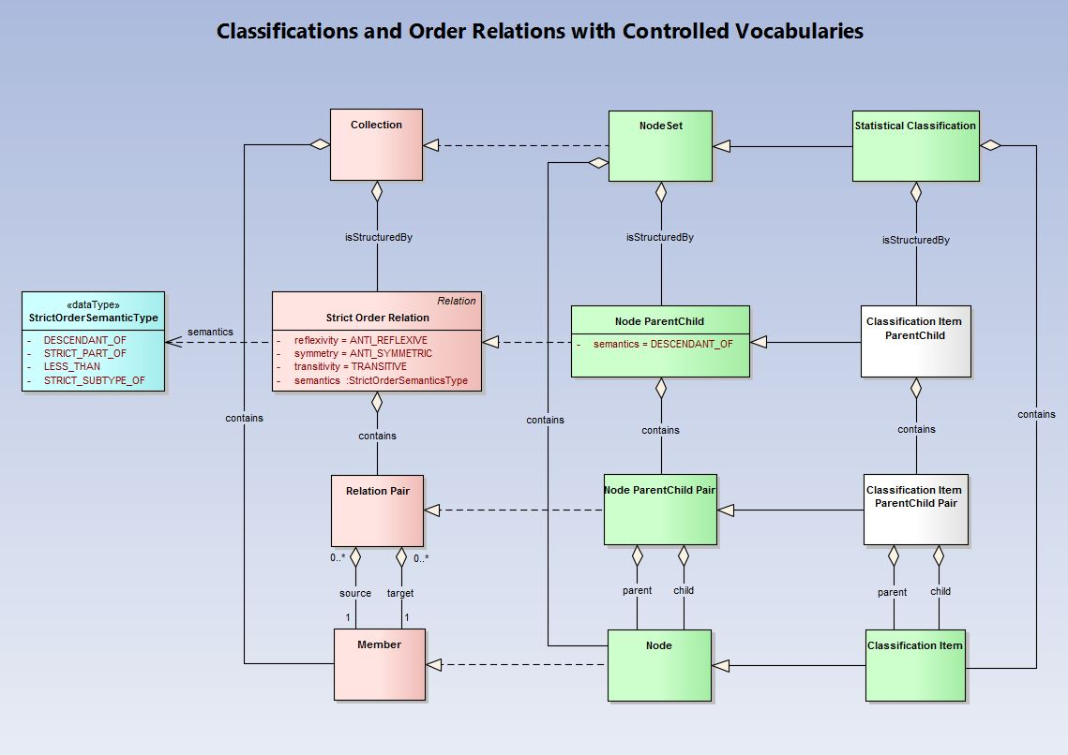
Figure 2
The classes in pink on the left are abstract. They are realized (dashed lines) by the four green classes in the middle. In turn, those Node-based classes are extended by the Classification ones on the right. Classes in green are part of the current model. The two classes in white are not there yet but I believe they are necessary to specify that a Statistical Classification is not structured by any Node Parent Child relation but by a specialization based on Classification Items.

Alternatively, we could model the relation’s semantics by specialized classes rather than controlled vocabularies. This second option of the model is shown next in Figure 3:
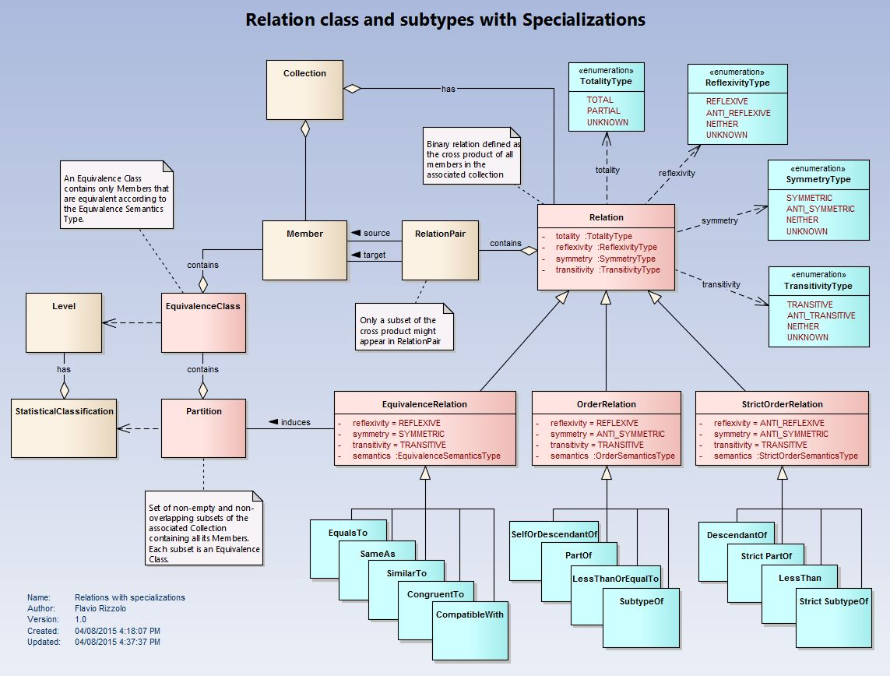
Figure 3
With this model the classification example of Figure 2 will look like the one depicted in Figure 4:
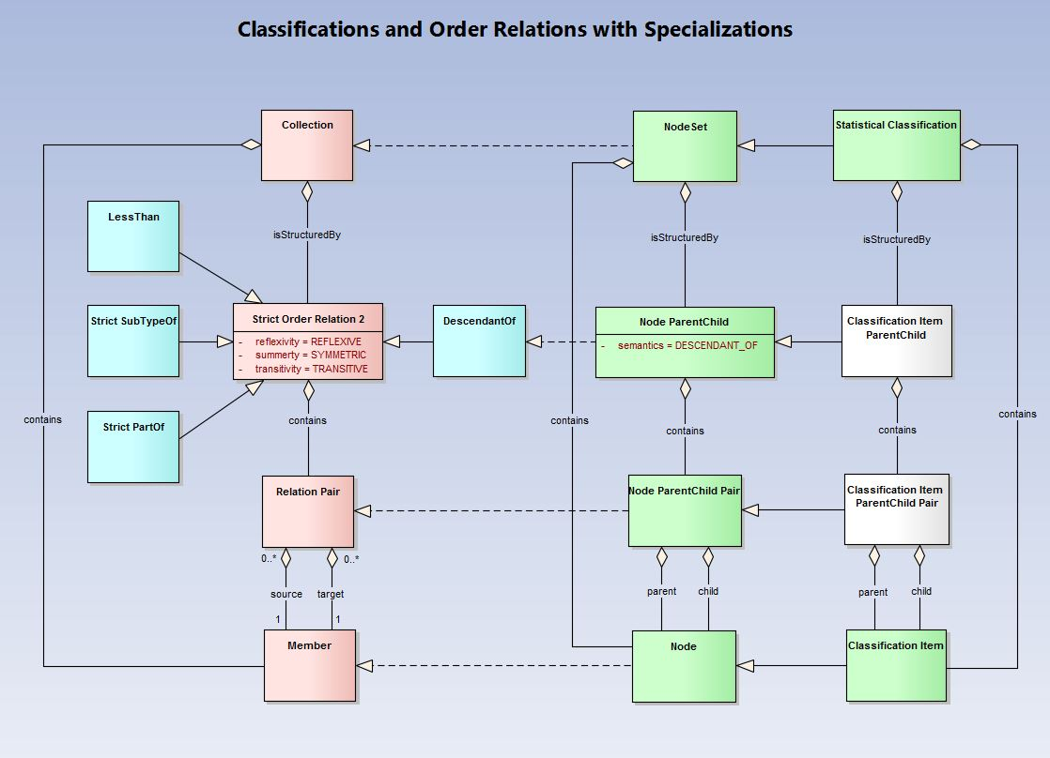
Figure 4

