GSIM “Node Set”
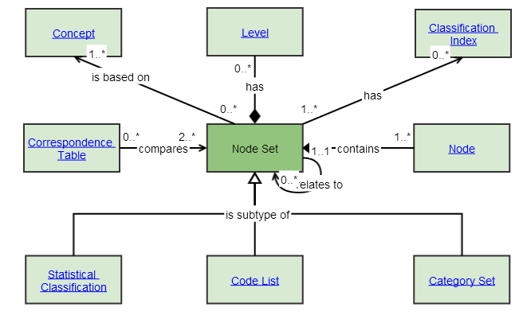

QUESTION from group:

It appears to allow a Node Set to relate to another Node Set which makes sense to us in terms of a Code List to a Code List or Category Set to a Category Set etc. However, it seems to allow that self-relate to subtypes of different types. Is that the case and if so, can you provide an example.

RESPONSE from Dan Gillman:
If I understand you correctly, the issue is that Node Sets can relate to other Node Sets, but since a Node Set can have many sub-types, is it meaningful to relate a Node Set (e.g., Category Set) to another Node Set (e.g., Code List)?
Let’s look at the following example:
Gender Category Set
Male gender
Female gender
Other gender

Gender Code List (1)
<m, Male gender>
<f, Female gender>
<o, Other gender>
Gender Code List (2)
<0, Male gender>
<1, Female gender>
<2, Other gender>
Clearly there is a relationship between these 3 sets. They agree on the underlying categories. In fact, the categories in the Category Set act as a pivot table to translate between the codes in the 2 Code Lists. For instance, gender data reported in Code List 1 is translatable to gender data reported in Code List 2 through the elements in the Category Set. Establishing the relationship between these Node Sets tells a user the translation is possible.
In the language of 11179, the Gender Category Set is a Conceptual Domain, and the two Gender Code Lists are Value Domains. The codes in the Value Domains are translatable because the Value Domains shares the same Conceptual Domain, i.e., categories are shared. The relationships in the metamodel for the standard show how that is done. In GSIM, this relationship is less explicit, but this is an example of why Node Sets of different sub-types should be relatable.

