Ability to Round-Trip Metadata Instances between Bindings
  - Modeling Team Design Position 2017-02-20
DDI users maintain their DDI content in a number of ways including as data base objects, XML instances, and RDF instances. Generally there is one binding that is determined to be canonical by the organization. There is often a need to move metadata from one binding to another to facilitate access or transfer of metadata. The intent is to support a lossless move of metadata between instances so that metadata stored in one binding type can be moved to another and back again without a loss of content. Note that the intent is to support this transfer as much of the round-trip nature of the metadata is based on providing the needed content.
The Modeling Team supports the ability to round-trip metadata instances between bindings with the following approach:
All transfer of metadata from one binding to another should be routed through the Platform Specific Model (PSM) and Platform Independent Model (PIM) structures
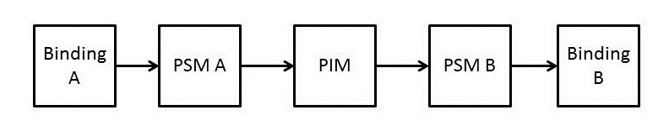
The round trip requires reversing the PSM to the PIM in order to use the knowledge found in the PIM
For example, if going from RDF or XML to Java you need to flatten characteristics of the classes and need to have access to the PIM in order to know where the abstract classes go.
For the Modeling Team this means:
- Keep the intersect in mind when doing the PIM to PSM processing
- Keep this translation process in mind for the RDB and JAVA-like languages. We need to retain the PIM in the translation process and this broadens the intersect set.
- We need to test this out as soon as we can to make sure this works - Use as a test of Codebook and Functional Bindings (XML and RDF).
- Avoid multiple inheritance

