ISCED Use Case

**Thanks to Hilda from NSC for contributing

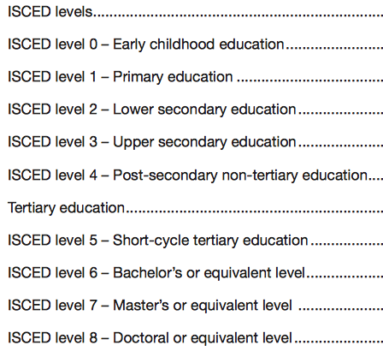

4 Post Secondary Non Tertiary Education
40 General Programmes
41 Education
42 Humanities & Arts

40 General Programmes
401 Basic programmes

41 Education
414 Teacher training and education science

42 Humanities and Arts
421 Arts
422 Humanities

401 Basic programmes
4010 Basic programmes

414 Teacher training and education science
4142 Education science
4143 Training for pre-school teachers
4144 Training for teachers at basic levels
4145 Training for teachers with subject specialization
4146 Training for teachers of vocational subjects

422 Humanities
4220 Humanities (broad programmes)
4221 Religion
4222 Foreign languages
4223 Mother tongue
4225 History and archaeology
4226 Philosophy and ethics

4140 Basic programmes
501101 Preparatory course for university or college education
501102 Preparatory course for college of engineering, county
501199 General programmes, unspecified, other, post-secondary
non-tertiary education
501999 General subjects, other, unspecified, post-secondary
non-tertiary education

4143 Training for pre-school teachers
521199 Pre-school teacher training, unspecified, post-secondary
non-tertiary education
521999 Pre-school teacher training, other, unspecified, post-
secondary non-tertiary education

4220 Humanities (broad programmes)
519999 Humanities and arts, other, unspecified, post-secondary
non-tertiary education

Orientation
General
501101 Preparatory course for university or college education
501102 Preparatory course for college of engineering, county
Vocational
501199 General programmes, unspecified, other, post-s econdary non-tertiary education
501999 General subjects, other, unspecified, post-secondary
non-tertiary education
519999 Humanities and arts, other, unspecified, post secondary non-tertiary education
521199 Pre-school teacher training, unspecified, post-secondary non-tertiary education
521999 Pre-school teacher training, other, unspecified, post-
secondary non-tertiary education

