DDI Example of Use: Data Capture
Contributors: Barry Radler, Dan Smith, Wolfgang Zenk-Möltgen, Kelly Chatain

Background

The Data Capture group was tasked with providing a simple use case against which they would test the existing Data Capture model. The bulk of the model was created in 2014 in Dagstuhl with slight modifications made in 2015. In reviewing the previous work, the team found additional changes had been made that required more specific attention and throughout the week identified a long list of issues that were logged in the Data Capture Jira Tracker. In addition to identifying missing or incorrect elements, the team also identified areas of redundancy and areas in which simplifications could occur. Additional discussions were had with the Data Description team regarding where the two models intersect, some details of which can be found in section C.

The Example:

The use case was specifically requested to test both the question class and the measurement class. The resulting example took the form of a permission form for a blood draw that included two questions, one routing instruction, and one measurement.
DDI Data Capture Use Case #1
Description: Permission form for blood pressure data capture performed in a clinical setting by a nurse or clinician.

Introduction: Please complete the following fields to provide permission for collecting a blood pressure reading.
Question1: “What is your full name?”
Description: Question with two separate responses; response options are open-ended text.
- First name ___________________
- Last name ____________________

Question2: May we perform a blood pressure reading on you?
Description: Question with one response; response option is closed-ended dichotomous category.
- Yes
- No

Measurement1: Instructions to Interviewer/Clinician: If participant provides permission, make sure participant is sitting. Remove any bulky clothing. Use stethoscope, watch, and blood pressure cuff. Attach blood pressure cuff and perform standard 30 second BP measure. Record blood pressure and pulse in the fields below.
Description: Measurement with three responses; response options are continuous numeric.
- Systolic blood pressure: _ _ _
- Diastolic blood pressure: _ _ _
- Pulse (beats per minute): _ _ _

B. Implementation of Example

The Model:

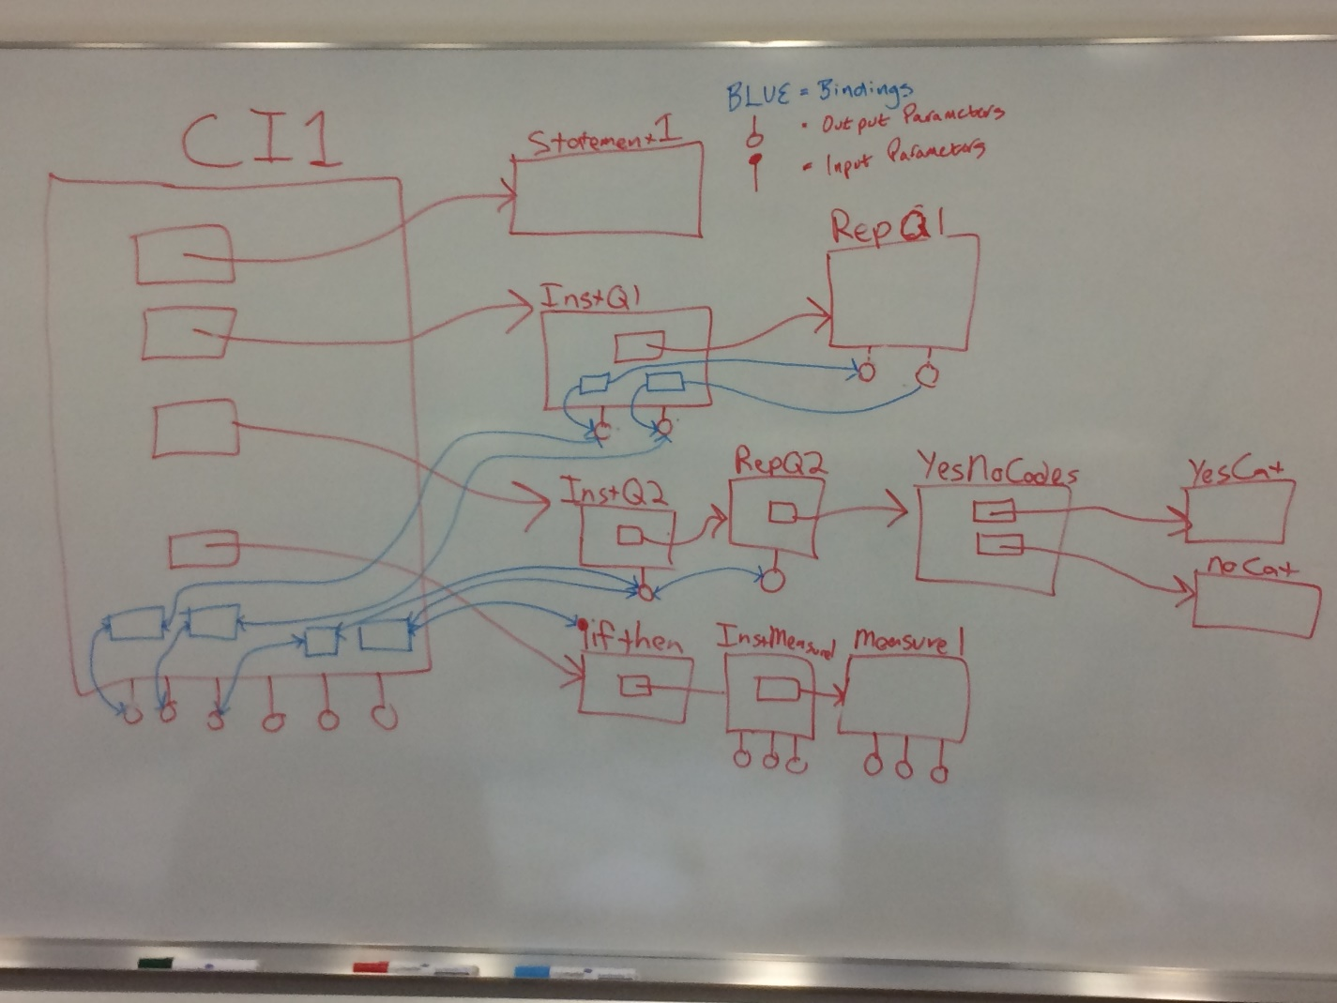
CI1 = Conceptual Instrument

KEY
[DDI Item type] Identification
-Property : value
--> relationship reference
(issue number) or ##issue described##

BEGIN EXAMPLE
[ConceptualInstrument] Instrument1
-hasAnnotation [Annotation]
- Title : "DDI Data Capture Use Case #1"
- abstract : "Permission form for blood pressure data capture..."
- contains [WorkflowSequence] --> Seq1
(DCAP-2)

[WorkflowSequence] Seq1
-defines [Binding] (DCAP-3)
-### source and target need reworking ###
-hasParameters
-contains [WorkflowStep]
--> Statement1
--> InstanceQ1
--> InstanceQ2
--> ifThen

[Statement] Statement1
-hasAnnotation [Annotation]
- Title : "Introduction"
-statementText [DynamicTextType]
-content : "Please complete the following fields to ..."
-audienceLanguage : "en-DE"
-content : "Please complete da following fields to ..."
-audienceLanguage : "en-US"

[InstanceQuestion] InstanceQ1
-name : Question1
-instantiates --> RepresentedQ1
-hasParameters
--> [Parameters] ParametersQ1
-output --> [OutParameter] ParameterQ1 ##No content in OutputParameter##

[RepresentedQuestion] RepresentedQ1
-displayLabel : "Name Question"
-purpose : "Capture a respondent's full name"
-hasResponseDomain
--> [TextResponseDomain] firstResponse
--> [TextResponseDomain] lastResponse
-questionText : "What is your full name?"
-OutParameter ##Need out parameters##

[TextResponseDomain] firstResponse
-displayLabel : "First Name"
-intendedRepresentation --> [RepresentedVariable] RepresentedFirstName

[TextResponseDomain] lastResponse
-displayLabel : "Last Name"
-intendedRepresentation --> [RepresentedVariable] RepresentedLastName

[RepresentedVariable] RepresentedFirstName
-name : RepresentedFirstName
-displayLabel : "First Name"
-##SubstantiveValueDomain is insufficient##

[RepresentedVariable] RepresentedLastName
-name : RepresentedLastName
-displayLabel : "Last Name"
-##SubstantiveValueDomain is insufficient##

[InstanceQuestion] InstanceQ2
-name : Question2
-instantiates --> ##TODO RepresentedQ2
-hasParameters
--> [Parameters] ParametersQ2
-output --> [OutParameter] ParameterQ2
##No content in OutputParameter##

[IfThenElse] ifThen
-condition [CommandCode]
-command [Command]
- programLanguage : "Barry pseudocode"
- commandContent : "if permission == 1"
-contains --> [WorkflowSequence] Seq2
-hasParameters
--> [Parameters] ParametersIfThen
-input --> [InputParameter ] ParameterIfThen
##No content in InParameter##
## aliased to "permission" ##

[WorkflowSequence] Seq2
-defines [Binding] (DCAP-3)
-hasParameters
-contains [WorkflowStep]
--> Measure1

[InstanceMeasurement] Measure1
-name : "Measurement1"
-instantiates --> RepresentedMeasure1

[RepresentedMeasurement] RepresentedMeasure1
-displayLabel : "Omron 10 Blood pressure reading"
-hasResponseDomain
--> systolicResponse
--> diastolicResponse
--> pulseResponse
-measurementType : "Omron10SeriesUpperArmBloodPressureMonitor"
-hasExternalAid --> manual1
-hasInstruction --> instruction1

[NumericResponseDomain] systolicResponse
-displayLabel : "Systolic blood pressure"
-intendedRepresentation --> [RepresentedVariable] RepresentedSystolic

[NumericResponseDomain] diastolicResponse
-displayLabel : "Diastolic blood pressure"
-intendedRepresentation --> [RepresentedVariable] RepresentedDiastolic

[NumericResponseDomain] pulseResponse
-displayLabel : "Pulse blood pressure"
-intendedRepresentation --> [RepresentedVariable] PulseSystolic

[ExternalAid] manual1
-typeOfMaterial : "pdf"
-descriptiveText : "Omron 10 manual"
-externalURLReference : "https://omronhealthcare.com/wp-content/uploads/BP786-IM.pdf"
-mimeType : "application/pdf"
-citationOfExternalMaterial
-title : "10 series Blood Pressure Monitor Model BP786 Instruction Manual"

[Instruction] instruction1
-instructionText : "Attach blood pressure cuff and perform..."

C. Additional Discussion

Linking to Data Description
There was a joint discussion with the Data Description group about how to link the models. The proposed solution was through the instance variable. The instance variable would link to the instance question, which links to the represented question, which then has the response domains. The represented question links to the represented variable, which encodes the response domains.
Two illustrations:
Illustration 1.
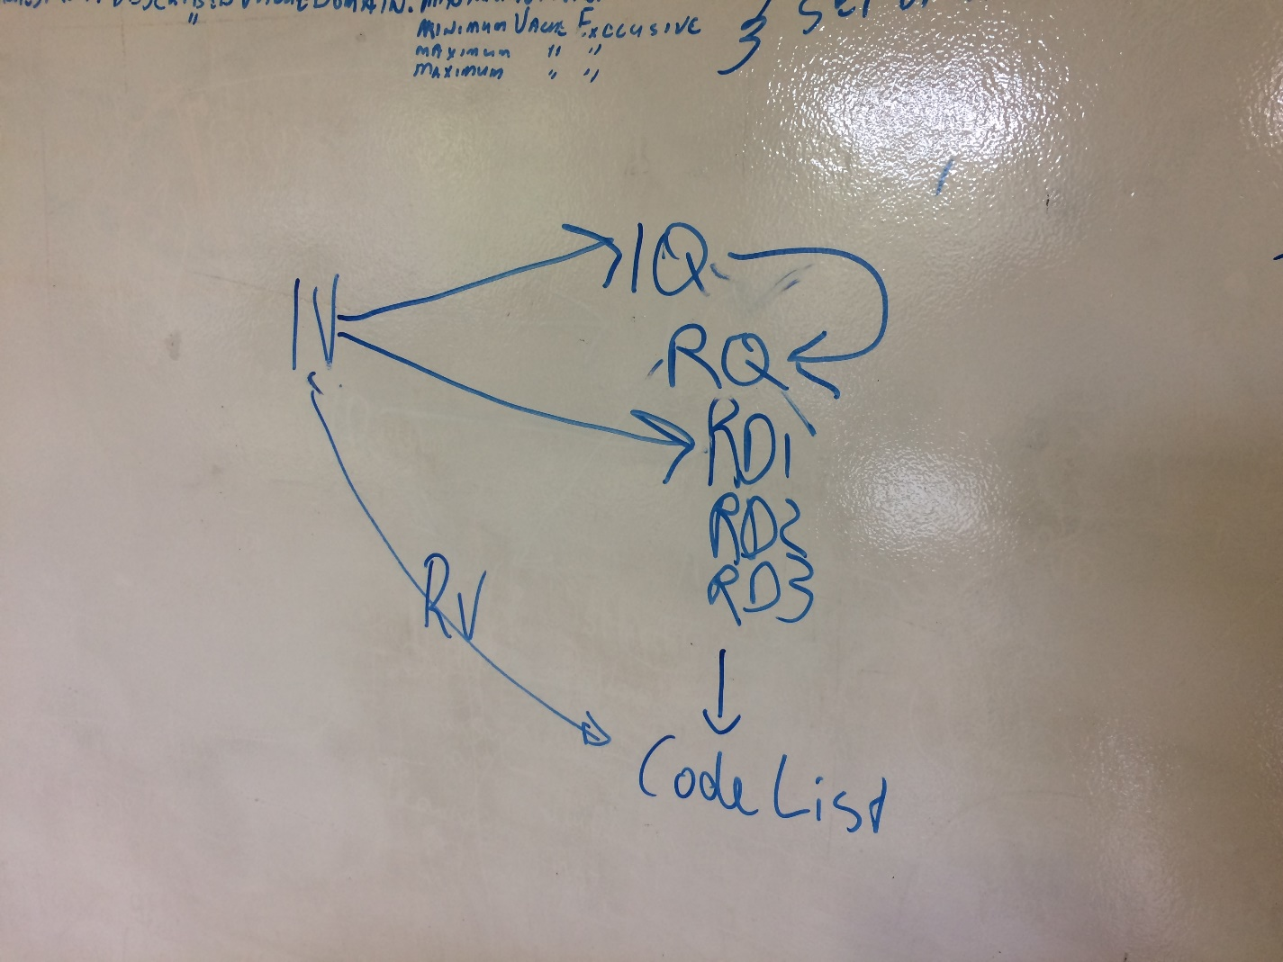
IV=instanceVariable
IQ=instanceQuestion
RQ=representedQuestion
RV=representedVariable
RD=responseDomain

Illustration 2.

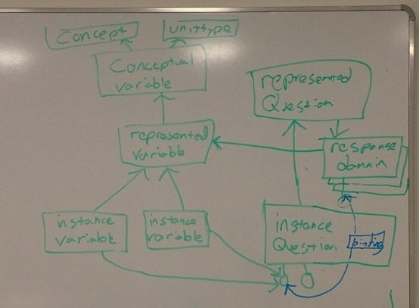

JIRA Issue Highlights:
Defining the In/Out Parameters (DCAP-5)
Workflow issues in general (DCAP-7, DCAP-8, DCAP-12, DCAP-20…)
Bindings (DCAP-3, DCAP-28, DCAP-29…)
Creating a touch point between Data Capture and Analysis (DCAP-32)
How to manage missing representation (DCAP-42)
Additional response domains to be created (DCAP-45, DCAP-47, DCAP-46)
Managing Code List Reponse Domains and being able to specify and “Other” response

