DDI Example of Use: [Aggregate Data]
Contributors:

Business Case
DDI-Views needs to be able to describe “aggregate files” also known as “Ncubes”. In this example, using the Australian Election Study 2013 data, unweighted statistics on the variable G1AGE were computed for all combinations of the variables A4 and STATE (see the SQL query below).
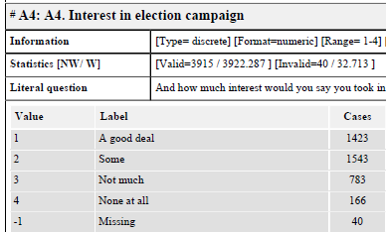
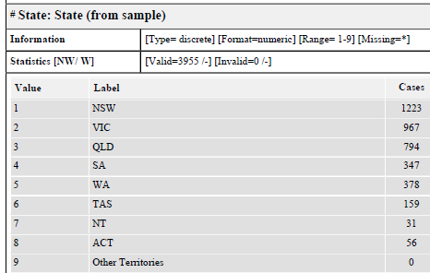
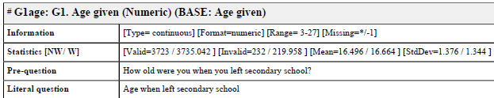

Data Preparation
The following SAS program was used to prepare the data from the aes_2013_01259.csv file:
libname Friday "C:\DDRIVE\projects\various\Dagstuhl\2016\week2\DataDescriptionExamples\DataDescriptionExamples\Friday";

PROC IMPORT OUT= WORK.AESwhole
DATAFILE= "C:\DDRIVE\projects\various\Dagstuhl\2016\week2\Da
taDescriptionExamples\DataDescriptionExamples\Friday\aes_2013_01259.csv"
DBMS=CSV REPLACE;
GETNAMES=YES;
DATAROW=2;
RUN;

data Friday.aes_2013_01259SubsetF;
set work.AESwhole;
keep DivisNum UniqueID DateComp State Division A4 G1Age XG5 Weight PartyABY SwingN;
run;

proc sql;
create table Friday.AES_Agregate as
select A4, State, mean(G1Age) as MeanG1Age, Min(G1Age) as MinG1Age, Max(G1Age) as MaxG1Age, count(*) as N
from Friday.aes_2013_01259SubsetF
group by a4, State;
quit;

PROC EXPORT DATA= FRIDAY.Aes_agregate
OUTFILE= "C:\DDRIVE\projects\various\Dagstuhl\2016\week2\Dat
aDescriptionExamples\DataDescriptionExamples\Friday\AESaggregate.csv"
DBMS=CSV REPLACE;
PUTNAMES=YES;
RUN;

Relevant Objects from the Model

Minimum Description Set

Item | DDI 4 Construct | Notes
Variable name | InstanceVariable.name
Variable label | InstanceVariable.displayLabel
Variable type | InstanceVariable.hasIntendedDataType
Variable value format | ValueMapping.physicalDataType
Variable value range | InstanceVariable.takesSubstantiveValuesFrom.DescribedValueDomain.minimumValueInclusive/minimumValueExclusive/maximumValueInclusive/maximumValueExclusive | Broken? Could be modeled as a class which allows for repeating segments within a range. Could change the SubstantiveValueDomain.DescribedValueDomain cardinality to 0..n 0..n. Same for SentinelValueDomain
Missing value | InstanceVariable.SentinelValueDomain
Statistics | Not in the model, other than the StatisticalSummary class in the “Keep” package | Not needed for minimum descriptor
Code scheme | InstanceVariable.SubstantiveValueDomain (CodeList, StatisticalClassification, etc.)
Sequence of variables | CubeLayout.PhysicalLayoutOrder.PhysicalLayoutOrderedPair.ValueMapping | Pairwise ordering of Variables - transitive
File name | Need to add – do we have a class representing the physical file? A DataStore is a logical construct (which oh by the way has a character set property – move to a class representing the physical instance?)
File 1st line variable names | CubeLayout.hasHeader/headerRowCount | CSVW has both, even though somewhat duplicative
Delimiter | CubeLayout.delimiter/isDelimited
File encoding | CubeLayout.encoding
End-of-line character | CubeLayout.lineTerminator
 | CubeLayout.hasHeader/headerRowCount
 | CubeLayout.PhysicalLayoutOrder.PhysicalLayoutOrderedPair.source/target.ValueMapping.formatsInstanceVariable
 | ViewPoint | ViewPoint contains IdentifierRole MeasureRole, and AttributeRole
 | IdentifierRole | Delineates which variables describe dimensions in the cube
 | MeasaureRole | Identifies which variables serve as measures in each cell of the cube
 | AttributeRole | Identifies which variables, if any, serve as attributes of the Cell.

Examples – Object Instances

The resulting CSV file is:
A4,State,MeanG1Age,MinG1Age,MaxG1Age,N
-1,1,16.875,15,18,8
-1,2,12.470588235,-1,19,17
-1,3,13.666666667,-1,20,6
-1,4,10.333333333,-1,17,3
-1,5,16,15,17,4
-1,6,16,15,17,2
1,1,16.085106383,-1,20,470
1,2,16.084142395,-1,20,309
1,3,15.083870968,-1,19,310
1,4,16.0546875,-1,19,128
1,5,15.603773585,-1,23,106
1,6,15.967741935,-1,18,62
1,7,17.3,16,19,10
1,8,16.214285714,-1,18,28
2,1,15.665217391,-1,19,460
2,2,16.012345679,-1,25,405
2,3,14.838283828,-1,19,303
2,4,15.464,-1,21,125
2,5,15.932098765,-1,19,162
2,6,15.3,-1,19,60
2,7,16.7,13,20,10
2,8,15,-1,18,18
3,1,14.864197531,-1,27,243
3,2,15.706806283,-1,22,191
3,3,14.832116788,-1,19,137
3,4,15.328947368,-1,19,76
3,5,14.471910112,-1,19,89
3,6,15.333333333,-1,18,27
3,7,13.1,-1,18,10
3,8,16.6,15,18,10
4,1,14.428571429,-1,18,42
4,2,13.711111111,-1,19,45
4,3,12.289473684,-1,19,38
4,4,12.8,-1,18,15
4,5,13.823529412,-1,19,17
4,6,11.875,-1,18,8
4,7,17,17,17,1

File-Level Metadata:
DDI 4 Construct | Values
Need to add – do we have a class representing the physical file? A DataStore is a logical construct (which oh by the way has a character set property – move to a class representing the physical instance?)
CubeLayout.hasHeader/headerRowCount | hasHeader = “true”/headerRowCount = 1
CubeLayout.delimiter/isDelimited | Delimiter = “,”/isDelimited=”true”
CubeLayout.quoteCharacter | Not applicable
CubeLayout.escapeCharacter | Not applicable
CubeLayout.encoding | ASCII
CubeLayout.lineTerminator | \n (line feed)
CodeList.contains.CodeItem.contains.Code | [Not in XML – we have a serious problem here. Model is way too deep. Simplify to agree with the pattern.]
CodeList.contains.CodeItem.contains.Code.denotes.Category.descriptiveText.content | [Category should be a specialization of Concept]
 | Note: Signifier is abstract and cannot be used directly as a datatype. Fix where needed.]
IdentifierRole/InstanceVariable – A4
IdentifierRole/InstanceVariable – State
MeasureRole/InstanceVariable - MeanG1Age
MeasureRole/InstanceVariable - MinG1Age MeasureRole/InstanceVariable - MaxG1Age
MeasureRole/InstanceVariable - N

Relationship to Other Standards/Vocabularies
[Describe any useful relationships with other models/standards/namespaces as appropriate, and at a fine level of detail if appropriate.]

XML Example
[Provide an example of the DDI 4 XML binding for the appropriate part of the model]

Adherence to Design Principles
[Look at the DDI 4 Design Principles and indicate rationale/discuss each in light of this example.]

