Process for the DDI 4

Development Project
Version 0.2 – 2 April 2014

I. Overview
This document proposes a work process and organization for the purposes of managing the DDI 4 development project. It is intended to be a living document, which may be changed as we work through the process. However, it is felt that having a documented and agreed process is important so that new staff (especially a new project manager) can more easily “ramp up” to participate in the process.
This document does not replace other documents created to help members of the various working teams perform their jobs within this process.

II. Proposed Work Process
The diagram below shows the high-level work flow. More detail can be found in other documents regarding the specific activities of the teams performing the functions shown here.
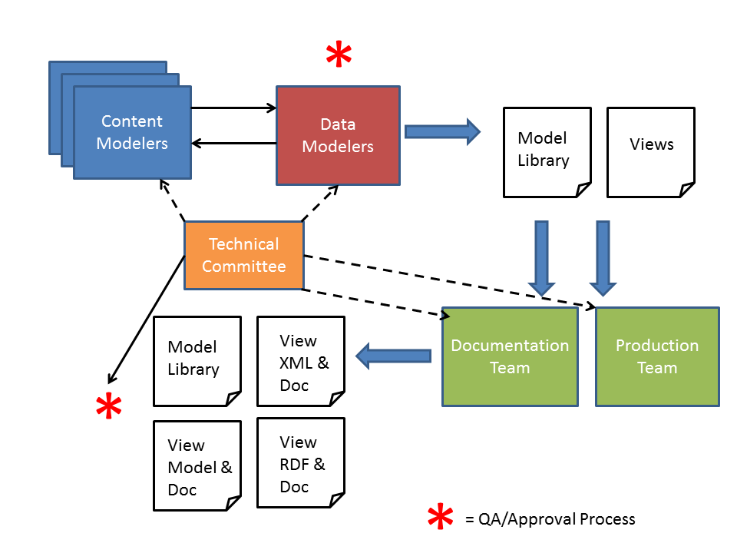
The flow is a fairly straightforward one: the Content Modelers work to produce a draft, which is critiqued by the Data Modelers. Corrections are made by both teams working together, until a final approved version is realized. This process will be the same for the Model Library and for the design of Functional Views.
When these products have been created there is an initial approval process, including members of the Content and Data Modeling teams [WHO EXACTLY IS INVOLVED HERE?]
The following issues should be addressed in the QA/Review process at this stage:
- Completeness of models
- Existence of documentation at Package Level and Object Level
- Consistency of modeling with other parts of the Model Library
- [WHAT ELSE DO WE CHECK HERE?]
Once approved, the Documentation team will get an exported Docbook file with the documentation as programmatically exported from Drupal, and the Production Team will get final versions of the models and views as XMI; diagrams produced by the Data Modeling team will go to both Production and Documentation teams, as needed.
The Production and Documentation teams will then work to programmatically produce the needed outputs from these inputs:
- View-based XML Schema
- XML Schema documentation
- View-based RDF/OWL Vocabulary
- RDF Documentation
- View Model XMI
- View Model Specification with documentation
- View EA file
- Model Library XMI
- Model Library Specification with documentation
When finalized, these outputs will go through a second round of QA/Review, conducted by the TC team, assisted by others as needed [WHO IS INVOLVED HERE BESIDES TC?]
This review process will check:
- [WHAT IS OUR CHECKLIST?]
At this stage, the work products are prepared by TC for circulation within the DDI Alliance for internal approval, and eventual publication for external review and approval.

III. Organization and Roles of Teams
There are several different teams and individuals involved in this picture. These are:
- Project Manager
- Technical Committee [TC]
- Content Modeling Teams
- Data Modeling Team
- Documentation Team
- Production Team
The roles of these are described below.
The Project Manager runs the overall process. Status and issues identified by any of the teams would be reported to the Project Manager, who coordinates the overall process.
The TC has several functions:
- Supporting the Project Manager in identifying solutions for issues found by the working teams
- Participating in each of the working teams, to help provide coordination and oversight
- Participating in the QA/Reviews, at each point in the process
- Reporting issues to the Project manager as these emerge
The Content Modeling teams work with a Data Modeler and a TC member (could be the same person) to create the models making up the Object Library, and to develop Functional Views. They are also responsible for all documentation at the Object level and the View level.
Data Modelers are responsible for the technical modeling and integration of the Objects into the Object Library, and the review and integration of Functional Views into the model. They are also responsible for producing diagrams for use in all documentation deliverables.
The Documentation Team is responsible for taking the diagrams produced by the Data Modelers and the Docbook export from Drupal, and editing and assembling these into the needed documentation outputs.
The Production team runs transformations on approved outputs to create XML schemas and RDF ontologies, and to assist the documentation team to produce a complete output package for the final QA/Review step.

ISSUES:
- At what point is syntax-specific documentation produced? How is it stored and managed?
- At which points are in-process deliverables published to Confluence? What are these?

