Organizer’s Questions/Notes for the HL7 FHIR Specification
In looking at the different specifications to be considered at the workshop, we have taken some time to review what is available on the website for HL7 FHIR. The goal of this activity was to help in organizing the workshop agenda, as this will to some extent be impacted by the areas where there is overlap or contact between the various specifications. Also, we hoped to gain some basic understanding of how data is modelled and encoded/formatted in the FHIR specification. None of us are implementers or experts in HL7 FHIR, so some of our questions may seem fairly naïve.
This document first describes what we found in looking at HL7 FHIR, along with some thoughts in terms of what kind of a specification it seems to be (as compared to DDI, for example). Following this, we also came up with some questions.

Summary of FHIR Data Objects/Website

Infrastructure Objects for Describing Resources
We noticed first that although there are several different bindings available for FHIR, there is a set of “infrastructure” classes whose function seemed to be the description of other resources. These include the “Element” object. We found the diagram below to be helpful in showing how such an approach works.
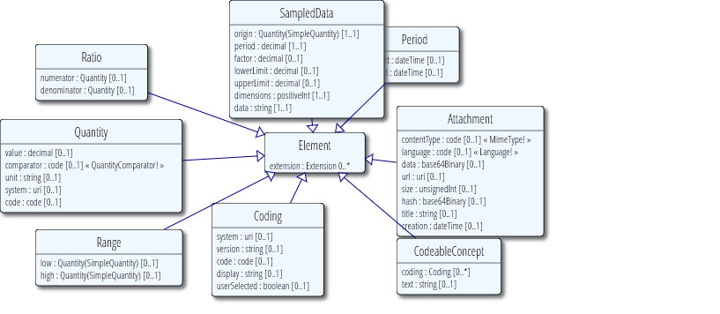
In addition, the set of different types (also extensions of the Element object) seemed obviously useful in describing specific resources, as shown below:
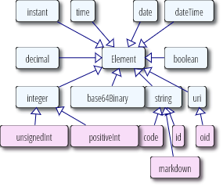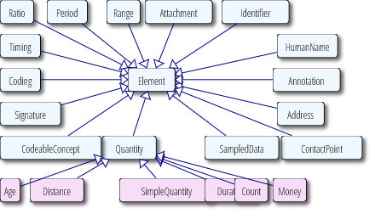
Primitive Types Complex data types

Given this set of tools, it seems possible to describe the different more specific types of potentially more complex resources. (This is many ways parallel to the modelling in DDI 4, interestingly, and in some other specifications such as SDMX).

FHIR as a Transaction Model
We also noticed that the fundamental goals of HL7 FHIR are different from those of DDI when it comes to describing data. Our understanding is that HL7 FHIR is at root an exchange or messaging standard, where the resources are described and bound for the purposes of conducting transactions. The way in which data is modelled (see below) thus happens in support of such exchange transactions between systems which could be considered “black boxes”.
For example, where DDI has a Questionnaire class, viewed as a means of capturing an entire data set covering many respondents, FHIR has a Questionnaire message accompanied by a QuestionnaireResponse, which would hold the observations not from an entire round of data collections, but for a single subject. In some ways the DDI Questionnaire and the FHIR Questionnaire are similar (they describe sets of questions) but the way the data they produce is typically addressed is in many ways different (at least in terms of how it is organized and described).
DDI focuses not on the exchange of data in a transaction, but on the production and management of data as a typically more persistent asset – a product to be used in research. This difference may seem subtle, but it does underlie many of the differences between these models as they regard data.

FHIR Data Description
The key object here seemed to be the Observation. The description of a FHIR observation accords well with the typical kind of data described by DDI. From the site:
“Expected uses for the Observation resource include:
  - Vital signs: temperature, blood pressure, respiration rate
  - Laboratory Data
  - Imaging results like bone density or fetal measurements
  - Devices Measurements such as EKG data or Pulse Oximetry data
  - Clinical assessment tools such as APGAR
  - Personal characteristics: height, weight, eye-color
  - Social history: tobacco use, family supports, cognitive status
  - Core characteristics: pregnancy status, death assertion”
These are very much the types of measurements which might be found in a typical DDI data set, for which a set of variables would be collected and described.
RE- Data Element Scope and Usage: “The scope covers base capabilities of the ISO 11179 Metadata Registries specification which defines DEs. It also covers observation definitions by ontologies such as LOINC. The term "observation" is interpreted in its broadest sense as "any element that might be thought of as the 'value' in a name-value pair". So it includes such concepts as patient gender, practitioner address and other data elements that would not typically be captured using the Observation resource. “
(These include the following):
- Patient - https://www.hl7.org/fhir/patient.html
- Medication
- Specimen
- Procedure
- Device

The FHIR documentation for Observation further states that a Diagnostic Report provides the workflow context for the set of observations. The function of a Diagnostic Report,, however, seems to be quite different from the typical DDI collection of data points, the Data Set.

Questionnaire and QuestionnaireResponse also provide useful perspective on the capture of data, but also on how individual observations are encoded from a single capture instrument. The picture below shows the UML of the Observation:
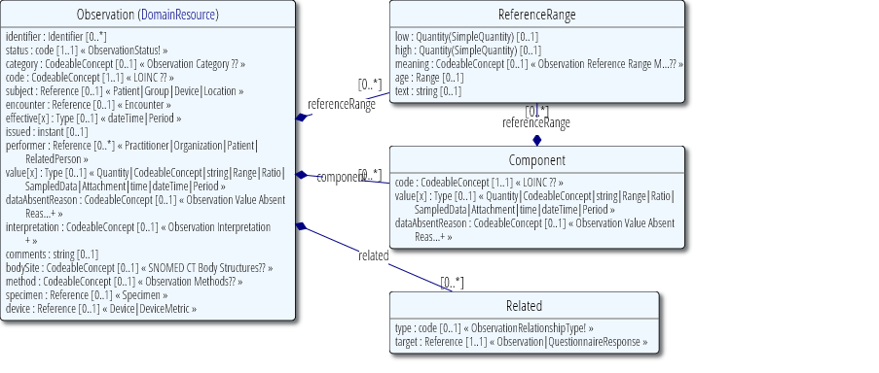
Some other classes in FHIR seemed to also potentially be of interest, including Value Sets, Structure Definitions, and Data Elements. These seem to correspond closely with some of the DDI constructs for describing data (Data Elements are similar to DDI Variables; Value Sets seem closely related to DDI Codes and Categories, and StructureDefinitions seem to correspond to a more complete description of a data set structure).

Questions
This fairly brief exploration of FHIR has given rise to several questions, some very general and some more specific:
- Have we missed any critical aspect of data description in FHIR? We are seeing some correspondences with DDI and some other specifications, but we could easily have missed something.
- Are we correct in thinking that the Element, Structure Definition, and Data Element objects are used by FHIR for describing FHIR resources? Did we miss anything critical in this picture?
- We understand how a Diagnostic Report can act as a collection of Observations (as can a Questionnaire). Are there other FHIR objects that perform a similar function to a Diagnostic Report?
I defer to Eric on this, but consider looking at Composition http://hl7.org/fhir/2016May/composition.html or
or List http://hl7.org/fhir/2016May/list.html
or Bundle http://hl7.org/fhir/2016May/bundle.html
- How does FHIR describe processes? We didn’t see any explicit (or at least, generic) process description. Did we miss something here? (Also, we noticed status codes – how do these relate to processes?)
We used the task resource to represent procedures http://hl7.org/fhir/2016May/task.html and we could have a list of tasks

