Structured Re-usable Documentation for DDI 4
Prepared by: Oliver Hopt, Jon Johnson, Amber Leahey

Introduction & Rationale
The documentation of DDI can be used for different purposes and for different audiences. The DDI 4 model is currently structured in such a way that makes the re-use of documentation difficult. A key goal of the working group is to identify structures and workflows that are better optimized for documentation re-use.
Changes to the documentation process could be made using such a structured approach. As new classes in the model are finalized, it would be required that this structure be completely populated to support the creation and re-use of documentation at the class-level. A class will thus be accompanied by rich documentation as well as the standard property and relationship sets.
The new documentation structure aims to meet two requirements:
1) to support re-use of documentation for different outputs based on the model;
2) enabling changes to the modelling process to capture better documentation
At a high-level, documentation flows through the modelling workflow for the production of DDI. As documentation becomes more structured with a view to certain purposes and audiences, it can be re-used throughout the model. At the class-level, the capture of additional types of documentation to support re-use greatly enhances the modelling process, reduces inefficiencies, increases understanding, and, enables the re-use of documentation for different purposes and audiences.
Audiences are particularly important for defining how documentation can be re-used, as certain audiences require certain types of documentation. Consideration of the audience, supports a view to reduce documentation burden, improve workflows across the model, and establish greater understanding and support for documentation re-use and training.
Finally a set of identified structured documentation approaches and guidelines are provided at all levels (high-level, functional view-level, and class-level) that can be applied to the model production, which supports the creation of rich documentation and re-use.

Section 1: Establishing a structured reusable documentation approach
In general, documentation should ultimately aim to improve people's understanding of DDI and how to use it. Structured documentation is required for the systematic re-use of information about how to document data in the DDI 4 model. Researchers and data documenters should be able to use a particular DDI View and document their data without knowing or understanding the underlying model for the standard. In order to adopt this kind of approach to documentation, we need to identify the important elements of documentation creation, the audiences, considerations and constraints that may determine use of documentation, and ideally how this will be used or made visible to users.

An overview approach for establishing structured re-usable documentation in DDI 4:

1. Identify audiences
2. Things to describe (model, classes, views)
3. How to do the things (technical people, non-technical people)
4. How to surface the things to different audiences

Using a structured documentation approach, it’s possible to address the documentation needs of some identified set of audiences, such as ourselves (DDI Moving Forward), deciders (managers, administrators), implementers (developers), and data documenters (data managers, researchers, etc.). Documentation requirements for the different audiences, includes identifying high-level and class-level documentation required for supporting migration by current users of DDI (Codebook and Lifecycle), linkages to glossaries, vocabularies, and definitions, and the requirements for defining relationships to existing documentation.

The following provides an overview of the documentation structure at the class-level and functional-view level. Moving forward all class items would be populated with the required documentation to support the goal of structured and re-usable documentation across the model. At the functional view level, documentation will take granular class items and provide users with what is recommended for use based on that functional-view.

Structured documentation at the Class-Level (CL) and Functional-View Level (FL):

Structured Documentation | Class-Level (CL) | Functional-Level (FL)
Formal Definition | Y | Y
Purpose | Y | Y
Relationship to existing documentation | Y | Y (Workflows)
Other specifications / domains | Y
Links to existing glossaries, vocabularies, definitions, etc. | Y
Technical examples | Y | Y (Use cases)

Implementing a structured documentation approach considers the production workflows that can support documentation re-use. Therefore to ensure that documentation is improved and structured, as documentation is captured at the varying levels, an evaluation of the different documentation production workflows is necessary.

Section 2: Structured re-usable documentation workflows
Drupal, the documentation tool used for the creation of the DDI 4 model, supports structured and versioned documentation for classes, views, and packages. Using the high-level overview of the model production workflow, and thinking about re-usable documentation, the goal is to produce as much as possible lossless class-level documentation and incorporate structured documentation in the production of the DDI outputs (XML, RDF, etc.). The export and inclusion of all class-level elements into the XMI from Drupal ensures richer documentation of the model and uses of it.

DDI 4 Documentation Production Model Workflow
Figure 1 - High-Level (HL)
The above diagram represents the documentation model production workflow (the transfer, exchange, and reuse of documentation in the DDI 4 model).

In order to facilitate the production and re-use of structured documentation for different purposes and different audiences, we currently need a mechanism for documenting recommended and excluded class-level documentation to be re-used in the creation of functional views and audience specific documentation.

Recommended documentation inclusions to support reuse
Figure 2 - Documentation inclusions at the Class-Level (CL)
In green – include under Definition field in the XMI (model)
M – Mandatory
T - Technical
TL - Technical Lite
Field | Output | XMI fields | Type
Name | Y | Y | M
Package | Y | Y | T
Extends | Y | Y | T
Is Extendable | N | N
Is Property | N | N
Status | N | N
Stage | N | N
Version* | Incorporate Drupal versioning - Y | ? | M
DDI 3.2 | Y | N | TL
GSIM | Y | N | TL
RDF Mapping | Y | N | TL
Contributor | N | N
Definition | Y | Y | M
Example | Y | N | M
Synonyms | Y | N | M
Explanatory Notes | Y | N | M
Overage Image | N
Properties* | Y | Y | M
Relationships* | Y | Y | M
PackageDescriptionName | Y | Y | M
FunctionalView | Y | Y | M

-add list of additional items to include & why they are needed
Controlled vocabularies

Section 3: Documentation for different audiences
Documentation can be structured and made re-usable if the incorporation of documentation “type” tags are added to class items. This can ensure certain types of documentation are provided to specific audiences. The following identifies a set of audiences and their documentation needs.
Figure 3 - Audience documentation needs / types
Audience | Types
Ourselves (Moving Forward) | everything
Deciders | M – High level
Developers | M + Technical
Documenters | M + T Lite
Researchers | M
Explain audience documentation needs (add from today)
Researchers & data documenters

Section 4: Examples and guidelines for use

Workflow Step example

Appendix: List of issues reported to JIRA (Structured re-usable documentation WG)
JIRA tasks, improvements, and new features added

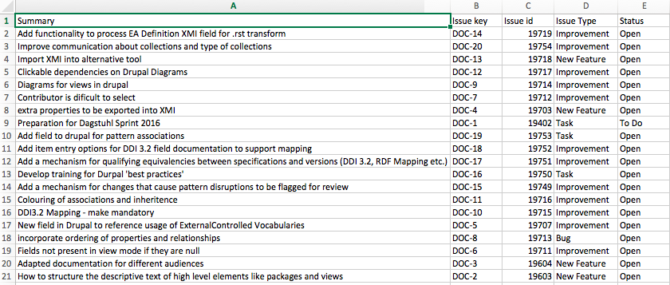

Progress to date
