Proposal:

MRT Group
Modeling, Representation, Testing Lifecycle
First part of proposal
A working group should be installed to focus on the iterative lifecycle of modeling, representation, and testing. This group would replace the previous modeling group.

The intention of combining modeling, representation, and testing in a iterative lifecycle has the goal to achieve an efficient production of the specification. Any major change on the model level can be immediately be evaluated on the other levels. The outcome of that can be fed into improvement on the different levels.

A combined approach for modeling, representation, and testing would enable a balanced perspective on the different needs. It would enable a robust model with robust representations. Both together are the DDI 4 specification not just the model.

The result of the work should be a first release of DDI 4. It would comprehend the model, the major representations, and the framework for modeling, generating the representations, and testing including generated documentation on all levels.

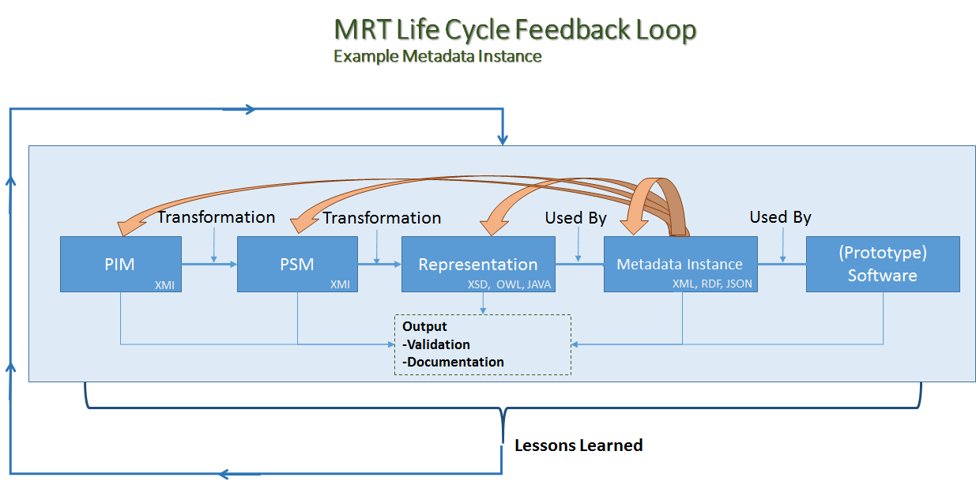.

The model needs to be improved according following requirements:
- Creating the model
  - Consistency of the model
  - Persistence of the model
  - UML conformance / usage of UML
- Using the model
  - With UML tools, connecting to other models
  - Subsetting the model, useful views
  - Supporting efficiently the main representations

The generation of representations needs transparent and straightforward transformation rules.

Second part of proposal
The focus should be on the core features of the prototype which comprehend mainly conceptual, data description, and process. These three areas are useful for different audiences, and use cases. They represent a common ground for different requirements.

A robust approach (regarding model and representations) for these three features would enable two things:
- Providing a core DDI 4 release which would be available for use
- Providing a robust “engine” for adding additional content features like data capture and others.

