Class Level Documentation enhancement

Requirements
- The capability to map between DDI-L and DDI-Views that is machine actionable.
- The capability to map between DDI-C and DDI-Views that is machine actionable.
- The capability to map between the DDI-Views Model and RDF objects for production of the RDF binding.
- The capability to map to existing and future DDI Controlled Vocabularies

Specification

Field_Property
The current Field Collection field_property is shown below
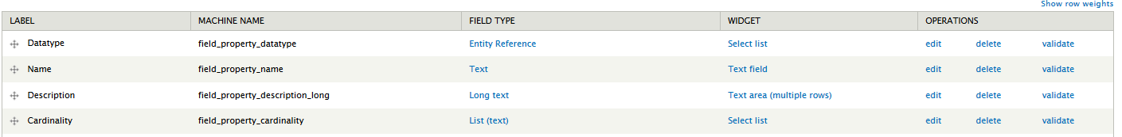
It should be extended to support the following
Label | MACHINE NAME | FIELD TYPE | WIDGET
DDI32 Class | field_property_ddi32_class | List (text) | Select List
DDI32 Property | field_property_ddi32_property | List (text) | Select List
DDI32 Match | field_property_ddi32_match | List (text) | Select List
DDI25 Element | field_property_dd25_element | List (text) | Select List
DDICV | field_property_ddicv | List (text) | Select List
DDICV_description | field_property_ddicv_description | Text | Text Field
RDF Mapping | field_property_rdf | Text | Text Field
RDF Match | field_property_rdf_match | List (text) | Select List

DDI32 Class
This field should be populated with the DDI3.x classes that currently reside is field_ddi_3_2

DDI32 Property
This field should be populated with DDI3.x properties, these should be restricted based on the content of DD32 Class

DDI32 Match
This field should be populated with a Controlled Vocabulary of appropriate terms

DDI25 Element
This field should be populated with the elements in DDI Codebook

DDICV
This field should be populated with the list of DDI Controlled Vocabulary URL. This field should only be available if the Property is on type ExtrenalControlledVocabulary

DDICV _description
A text field for explanatory notes relating to the DDICV field

RDF Mapping
A text field to hold the URL of the relevant RDF mapping

RDF Match
This field should be populated with a Controlled Vocabulary of appropriate terms

field_relationship
This should be extended to add the following fields
Label | MACHINE NAME | FIELD TYPE | WIDGET
RDF_Relation | field_property_rdf_relation | List (text) | Select List
RDF_Relation_Target | field_property_rdf_relation_target | Text | Text Field

RDF Relation
This field should be populated with a Controlled Vocabulary of appropriate terms

RDF Relation Target
A text field to hold the URL of the relevant RDF Target

Implementation Considerations
The fields can all be added by an administrator, without the need to Drupal skills. Set up of the content to populate the lists for can be done without programmer time
- DDI32 Match
- RDF Match
- RDF_Relation

Programmer Time
Drupal skills will be required to import data into the fields, and potentially the dependency between DDI32 Class and DDI32 Property.

