From Jenna (ICPSR graphic designer: “Looks like the last time it was printed was the end of 2009. I've attached the most recent pdf we have. If you want to pull text out or use the brochure but modify it slightly, I have all of the files (indesign, pdf, and images) as far as I can tell.”

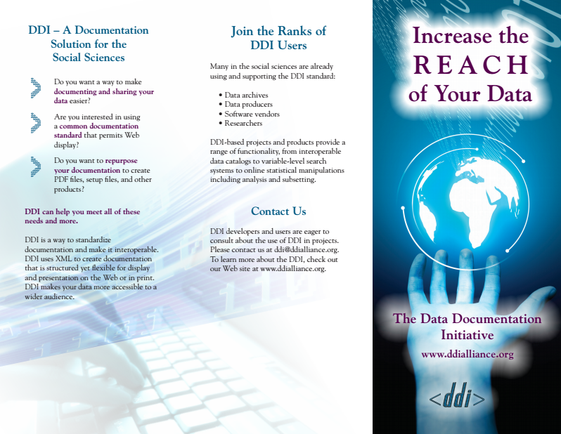
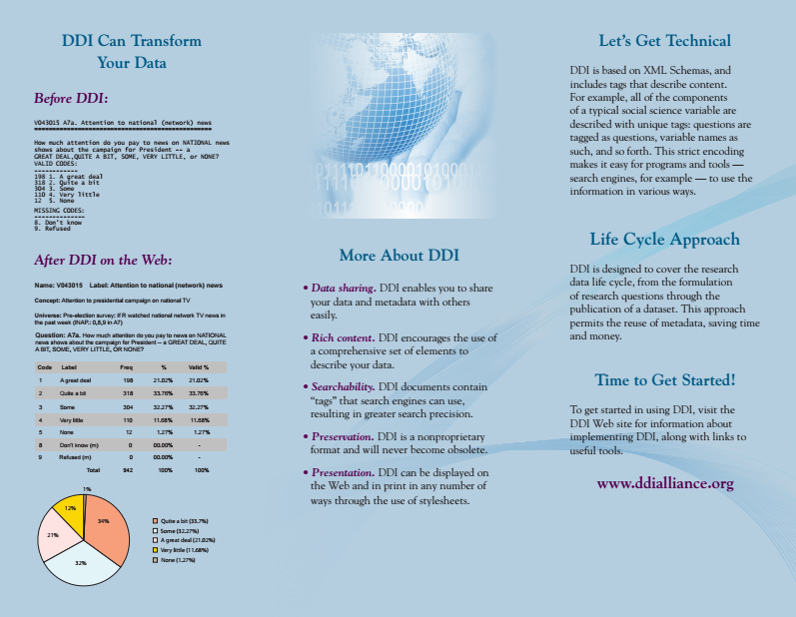

- The before/after section is nice. Conveys what DDI can do.

