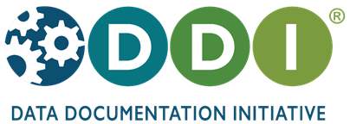

an international standard for describing the survey research lifecycle

www.ddialliance.org

DDI encourages comprehensive description of data for discovery and analysis and supports effective data sharing. Because DDI is a structured standard, it facilitates machine-actionability and interoperability and it can be used to both document existing data and drive systems to create new data. Another feature of DDI is its focus on metadata reuse; “enter once, use often” means you can reuse metadata over the course of the data life cycle to avoid costly duplication of effort.

DDI is a free and open standard. It ensures that your data are:
• Documented
• Discoverable
• Interoperable

DDI is being used in over 60 countries around the world. Major projects producing DDI include:

- CLOSER – UK longitudinal studies
- Consortium of European Social Science Data Archives
- German Microcensus Data Archives
- International Household Survey Network (IHSN)
- German Microcensus Data Archives
- Midlife in the U.S. (MIDUS) longitudinal study
- Statistics Canada
- Statistics Denmark
- U.S. Bureau of Labor Statistics

You are invited to learn more about DDI at a reception:
Friday, May 13th, from 6-8pm
Hilton Garden Inn Austin Downton, HGI-Training Room
500 N Interstate 35, Austin – just a 5 minute walk from the AAPOR conference hotel

one rich ddi metadata file can yield multiple dynamic outputs
DDI is designed to describe the research data life cycle, from the creation of research questions through the publication and sharing of a dataset. Tools can utilize existing metadata, for example, by reusing questions and codelists to ease provenance and accuracy in the management of survey development. DDI also leverages concept management and provides structures to ease harmonization of variables, so you can reuse metadata from project planning to instrument design to dataset production to documentation – and even reuse again in the next project.

