DDI Marketing and Partnership Group Minutes
11/18/2020

Conference call
Attendees:

Agenda
- Research update
  - Kelly’s report
  - Analysis – how to?
    - Limits on sharing results
    - Idea: ask to share more broadly than EB; ensure anonymity and de-identification;
    - Idea: ask UM SRO IRB for interpretation;
  - Consider wording change in future versions.
  - Send thank you packet to respondents:
    - With remote working, best way to reach?
    - Table this idea until folks back at work
      - Tchakis
      - Brochures
      - Send similar to all DDI members
        - Generate awareness both ways.
        - Need mailing addresses
    - Virtual packets or alternatives?
      - Zoom background?
    - Thank you followup email (Jared and Steve) after digesting results.
- DDI product logos
- 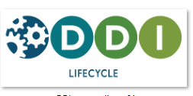
  - Marketing group suggests product names could be larger
    - Different icons/colors could lend visual distinction, e.g.:
    - 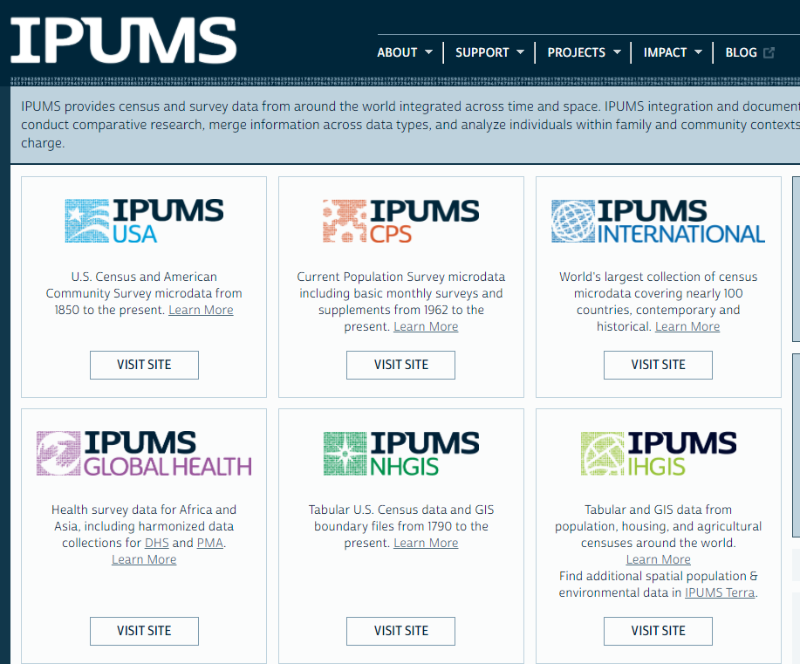
  - Color scheme for font/background for each.
  - Shrink DDI text, enlarge product text.
  - Legacy history coming up with current logo? Who was involved? Training?
- Website updates
  - Responsibility for updating content pages
  - E.g., Tools, need to identify and clean broken links (Michael)
- DDI Alliance assistant for helping working groups
  - ICPSR staff 20%, December thru May
- Promoting suite – some support for a bundled year-end announcement – Press Release
  - Promoting “DDI Lifecycle (3.3)”
    - Emphasize simplicity and tools
      - Need an elevator speech.
    - Webinars ala SDTL, even Scientific Board
    - Remember: upcoming 2.6 release.
  - SDTL newest DDI product approved by membership
  - ISO vote for Codebook and Lifecycle
  - CDI review and development
- Does it exist? What’s in it?
- Content versus coverage.

Future Agenda: Membership retention and recruitment – new group discussed at EB.

- Research update
  - Kelly’s report
  - Analysis – how to?
    - Limits on sharing results
  - Send thanks you packet to respondents:
    - Brochures
    - Tchakis (Slap bracelets (re-order – they are popular)
        - DDI lanyards (can be reused for many conferences)
        - Buttons – small ones not as effective
          - “Ask me about DDI”
        - Glasses chamois
        - Flashlights
        - Die-cut sticker with DDI logo
        - Have: USB drive (caribinnear), buttons, pens, ice cubes.
    - Send similar to all DDI members
      - Need mailing addresses
- DDI product logos
  - Website updates
- Promoting suite
  - Promoting “DDI Lifecycle (3.3)”
  - Press release
    - Emphasize simplicity and tools
      - Need an elevator speech.
    - Need to update Tools page
  - ISO vote

Dan Smith shared the following examples of Press Releases for other metadata standards having new releases or versions
https://www.ogc.org/pressroom/pressreleases/3147
https://www.w3.org/2019/12/pressrelease-wasm-rec.html.en
https://www.niso.org/press-releases/2017/01/niso-publishes-understanding-metadata-primer
https://iptc.org/about-iptc/media-releases/14-11-25/
niso.org
NISO Publishes "Understanding Metadata" Primer | NISO website
The National Information Standards Organization (NISO) continues its Primer Series with the publication of Understanding Metadata. This comprehensive overview of information about an item's creation, name, topic, features, and more updates NISO's 2004 advice on the subject and joins a series that has also covered research data management.
iptc.org
IPTC Photo Metadata extended to be more precise and reliable - IPTC
IPTC is the global standards body of the news media. We provide the technical foundation for the news ecosystem.

